In sensor fusion, the weighted average is a method to combine measurements from multiple sensors. The formula for the weighted average is:
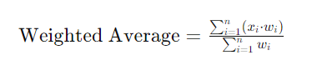
Where:
- xi​ represents individual measurements from sensors.
- wi​ represents the weights assigned to each sensor's measurement.
- n is the total number of sensors.
This formula calculates a weighted average of measurements, where each measurement is multiplied by its corresponding weight, and the result is divided by the sum of the weights.

Question:
A weather forecasting system employs three sensors to predict the wind speed in a coastal region: Sensor X, Sensor Y, and Sensor Z. Sensor X provides a mean wind speed measurement (µ) of 25 km/h with a standard deviation (σ) of 3 km/h. Sensor Y offers a mean measurement of 28 km/h with a standard deviation of 2.5 km/h, and Sensor Z has a mean measurement of 23 km/h with a standard deviation of 3.2 km/h.
The sensor fusion system assigns different weights to each sensor's wind speed measurement:

Sensor X: Weight = 0.4
Sensor Y: Weight = 0.3
Sensor Z: Weight = 0.3
Calculate the weighted average wind speed predicted by the sensor fusion system for the coastal region.

Solution:
To calculate the weighted average wind speed, we'll use the weighted average formula:
Where:
- x1​ is the mean wind speed of Sensor X = 25 km/h
- x2​ is the mean wind speed of Sensor Y = 28 km/h
- x3​ is the mean wind speed of Sensor Z = 23 km/h
- w1​ is the weight assigned to Sensor X = 0.4
- w2​ is the weight assigned to Sensor Y = 0.3
- w3​ is the weight assigned to Sensor Z = 0.3
Now, let's calculate the weighted average wind speed:
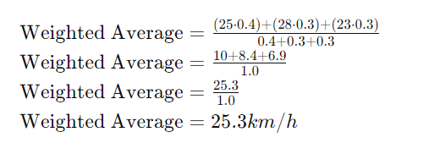
The sensor fusion system predicts a weighted average wind speed of 25.3 km/h for the coastal region. This combined prediction takes into account the measurements from all three sensors, with Sensor X having the highest weight in the fusion process.

